
RAMAIAH
Institute of Technology
USN | 1 | M | S

(Autonomous Institute, Affiliated to VTU)
(Approved by AICTE, New Delhi & Govt. of Karnataka) Accredited by NBA & NAAC with ‘A’ Grade

MAKEUP EXAMINATIONS – JULY 2019

Course & Branch | : | B.E. : Computer Science and  Engineering | Semester | : | IV
Subject | : | Data Communication | Max. Marks | : | 100
Subject Code | : | CS44/CS1544 | Duration | : | 3 Hrs

Instructions to the Candidates:
- Answer one full question from each unit.

 |  | UNIT- I
1. | a) | Differentiate between star bus and ring topology with their advantages and disadvantages. | CO2 | (08)
 | b) | What is the total delay (latency) for a frame of size 5 million bits that is being sent on a link with 10 routers each having a queuing time of 2 µs and a processing time of 1 µs. The length of the link is 2000 Km. The speed of light inside the link is 2x10⁸ m/s. The link has a bandwidth of 5 Mbps. Which component of the total delay is dominant? Which one is negligible? | CO1 | (06)
 | c) | Match the following to one or more layers of the TCP/IP protocol suite:  i) route determination  ii) connection to transmission media  iii) providing services for the end user  iv) creating user datagrams  v) responsibility for handling frames between adjacent nodes  vi) transforming bits to electromagnetic signals. | CO1 | (06)
2. | a) | In the TCP/IP protocol suite, outline and discuss the identical objects at the sender and the receiver sites when we think about the logical connection. | CO1 | (06)
 | b) | Discuss the three causes of transmission impairment when signals travel through transmission media? What is the theoretical capacity of a channel when Bandwidth: 20 KHz and SNR_{dB} =∇40. | CO1 | (06)
 | c) | Explain the structure of internet with a block diagram. | CO1 | (08)
 |  | UNIT- II
3. | a) | Draw the signal patterns for Unipolar, NRZ-L, NRZ-I, Manchester, differential Machester, AMI and pseudoternary line coding scheme for the data stream 11100011. | CO2 | (06)
 | b) | What is signal impairment? List and explain the reasons for impairment. | CO2 | (08)
 | c) | Define constellation diagram and its role in analog transmission. | CO2 | (06)
4. | a) | Define data rate and signal rate. Explain the following characteristics of line coding scheme.  i) Baseline Wandering ii) DC components iii) Self-synchronization. | CO2 | (08)
 | b) | What is the Nyquist sampling rate for each of the following signals?  i) A low pass signal with bandwidth of 200kHz.  ii) A band pass signal with bandwidth of 200kHz if the lowest frequency is 100kHz. | CO2 | (04)
 | c) | Illustrate the process of quantization and encoding of the sampled signals with amplitude values (-6.1, 19.7, -11.3, -6.0) in pulse code modulation. | CO2 | (08)
 |  | UNIT- III
5. | a) | Design a multistage switch with three stages and find the number of cross points. | CO3 | (10)
 | b) | “The actual communication in a circuit-switched network requires three Phases”. Explain each phase in detail. | CO3 | (10)
6. | a) | What is CRC? If the generating polynomial for CRC is and message is 11110000, compute the code word. | CO3 | (10)
 | b) | Elaborate the concept of parity checking. Explain the encoder and decoder for a simple parity check code with a supporting diagram. | CO3 | (10)
 |  | UNIT- IV
7. | a) | Differentiate bit stuffing and byte stuffing and discuss their importance in communication. | CO4 | (08)
 | b) | Why should the size of the sender and receiver windows in selective repeat protocol can be at most one-half of 2^{m}? Justify with examples. | CO4 | (06)
 | c) | Draw a flow diagram for CSMA/CD and give its limitation. | CO4 | (06)
8. | a) | Draw a Sender and Receiver FSM for Go Back N protocol. | CO4 | (08)
 | b) | Explain Challenge Handshake Authentication Protocol. | CO4 | (06)
 | c) | Illustrate the working of Code Division Multiple Access with examples. | CO4 | (06)
 |  | UNIT- V
9. | a) | Distinguish between unicast, mlulticast and broadcast transmission. | CO5 | (06)
 | b) | List the goals of Gigabit Ethernet. | CO5 | (06)
 | c) | With a neat block diagram explain Ethernet frame format. | CO5 | (08)
10. | a) | Explain spanning tree algorithm with an example. | CO5 | (08)
 | b) | Explain point coordination function and give an example of repetition interval. | CO5 | (06)
 | c) | In Fig.10(c) below, two wireless networks, BSS1 and BSS2, are connected through a wireless distribution system (DS), Assume station A in BSS1 needs to send a data frame to station C in BSS2. Show the value of addresses in all communication sections : from station A to AP1, from AP1 to AP2, and from AP2 to station C.  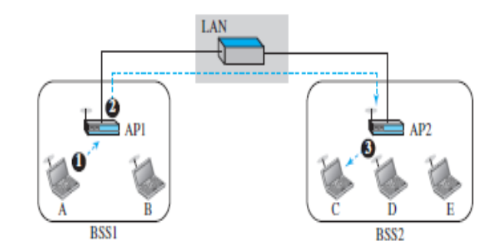  Fig.10(c) | CO5 | (06)

****************

